Web Hosting

git clone <https://github.com/Anuj1990/SpringBootDocker.git>

ls -lart

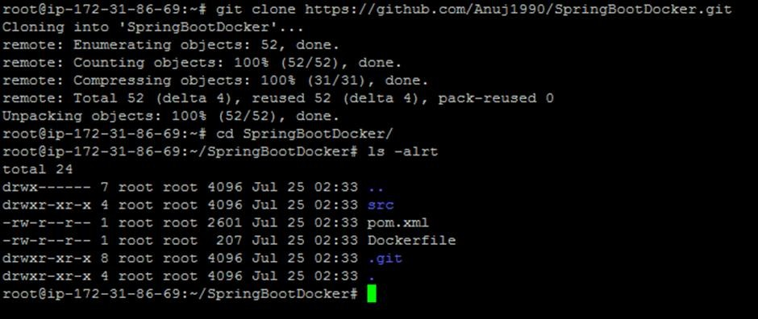

mvn clean install

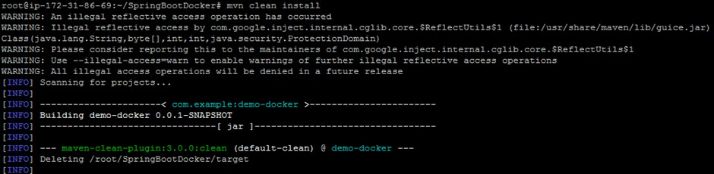

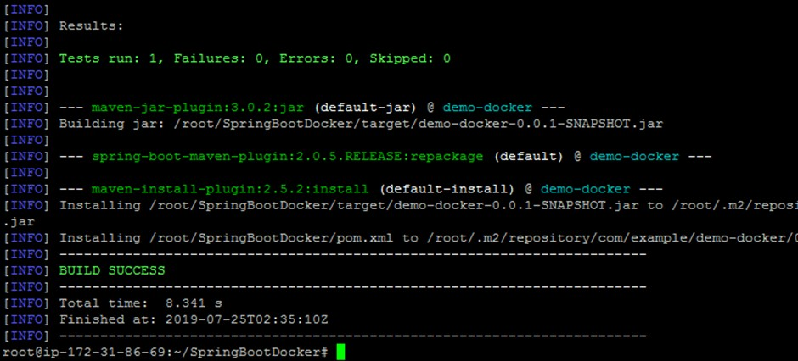

docker build -t springbootapp

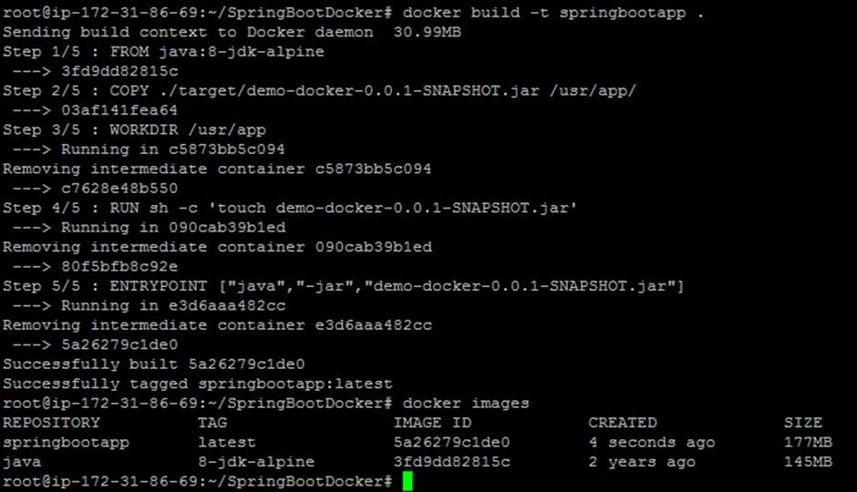

docker images

docker tag springbootapp anujsharma1990/springboot docker push anujsharma1990/springboot

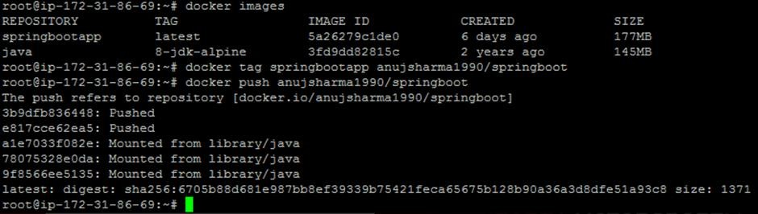

export PATH=$HOME/bin:$PATH kubectl get node

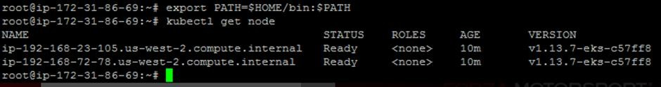

kubectl run springbootapp--image=anujsharma1990/springboot --port=8080

kubectl expose deployment/springbootapp --port=8080 --target-port=8080 -- type=LoadBalancer

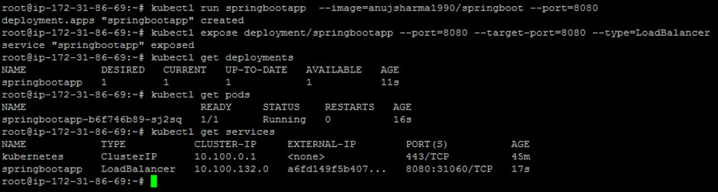

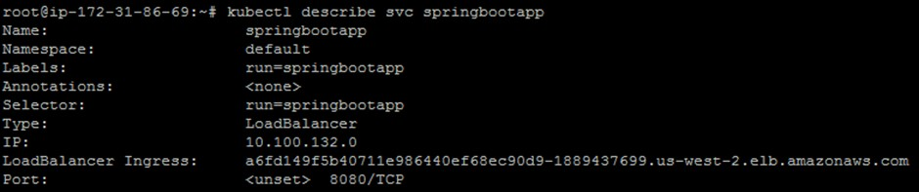

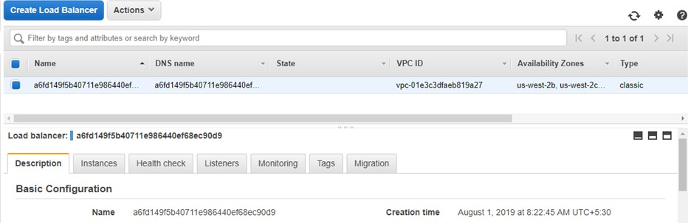

curl -w "\n" a6fd149f5b40711e986440ef68ec90d9-1889437699.us-west- 2.elb.amazonaws.com:8080/greet/EKSSpringboot

